**Name : Sharma Anish Ashok**

**Roll No : 11**

**SAP ID : 60003220045**

**Branch : Information Technology**

**Div : D**

**Batch : IT1**

**Experiment No. 6**

Write a program to count the number of digits in a given integer.

**Aim :**

Counting the number of digits in a given integer.

**Code :**

#include<stdio.h>

#include<conio.h>

void main()

{

int num,count=0,rem;

//clrscr();

printf("Enter your number:\n");

scanf("%d",&num);

while(num>0)

{

count++;

num=num/10;

}

printf("\n Total number of digits in given number: %d",count);

getch();

}

**Output :**

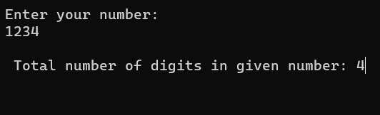

**Conclusion :**

We understand the use of while loop and how to count number digits in given number.

**Experiment No. 7**

Write a menu driven program to perform simple arithmetic operations based on the user's choice. The user will indicate the operation to be performed using the signs e.g. + for addition, etc. Write an algorithm and draw flowchart for same.

**Aim :** Use of switch in making simple calculator

**Algorithm :**

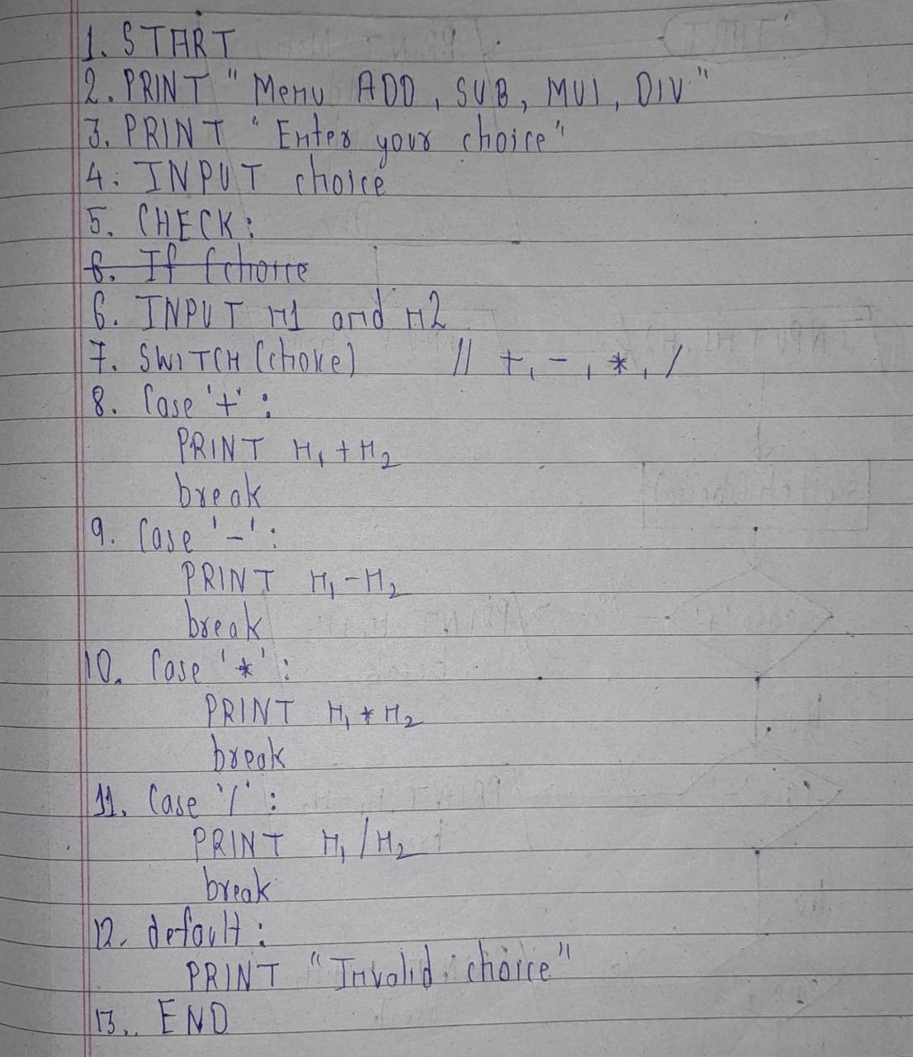

**Flowchart :**

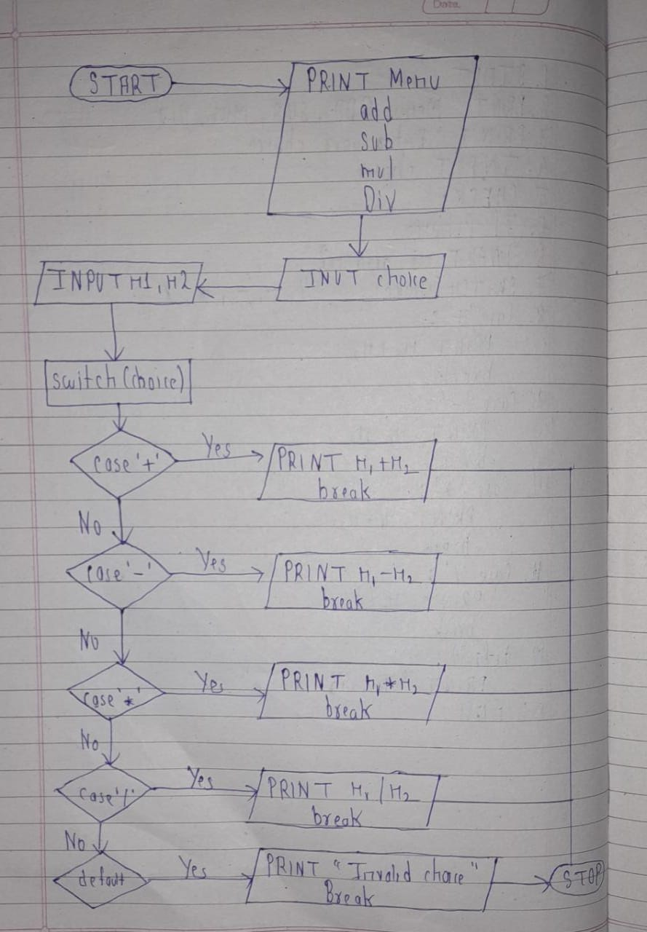

**Code :**

#include<stdio.h>

#include<conio.h>

void main()

{

int n1,n2;

char choice;

//clrscr();

printf("Menu of Simple calculator\n");

printf("+. Addition\n-. Subtraction\n*. Multiplication\n/. Division");

printf("\nEnter your choice according to the Menu:\n");

scanf("%c",&choice);

printf("\nEnter two number:\n");

scanf("%d %d",&n1,&n2);

switch(choice)

{

case '+':

printf("\nAddition of two number is %d",n1+n2);

break;

case '-':

printf("\nSubtraction pof two number is %d",n1-n2);

break;

case '*':

printf("\nMultiplication of two number is%d",n1*n2);

break;

case '/':

printf("\nDivision of two number is %d",n1/n2);

break;

default:

printf("\nEnter valid number");

}

getch();

}

**Output :**

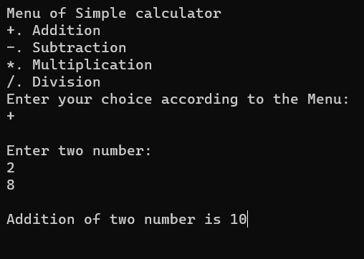

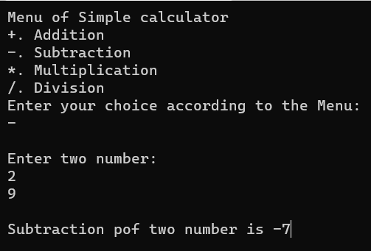

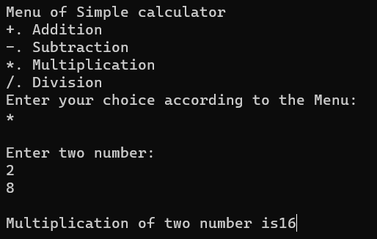

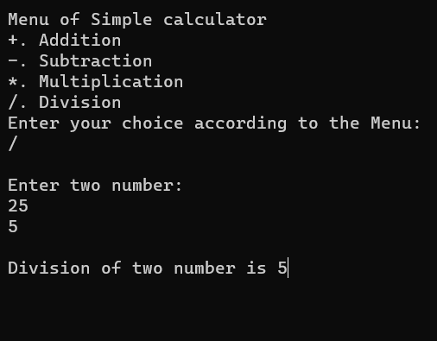

**Conclusion :**

We understand the concept of switch statement in above given program.

**Experiment No. 8**

Write a program to read a number of more than one digit, reverse the number and display the sum of digits of numbers. Write algorithm and draw flowchart for the same.

**Aim :**

reverse the number and display the sum of digits of numbers

**Algorithm :**

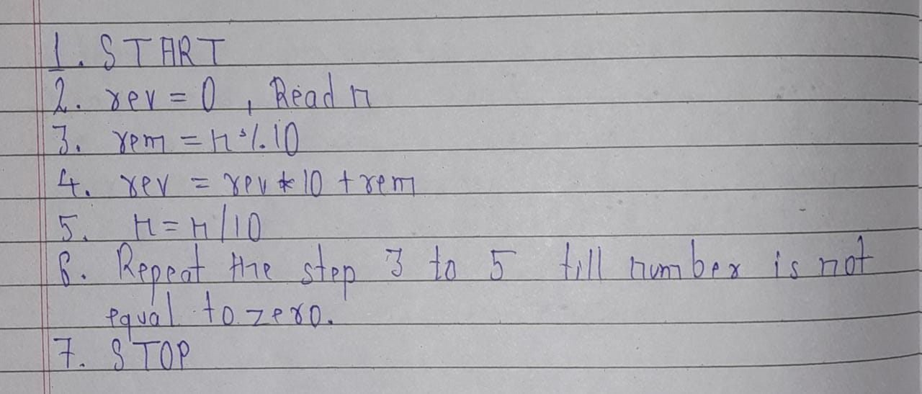

**Flowchart :**

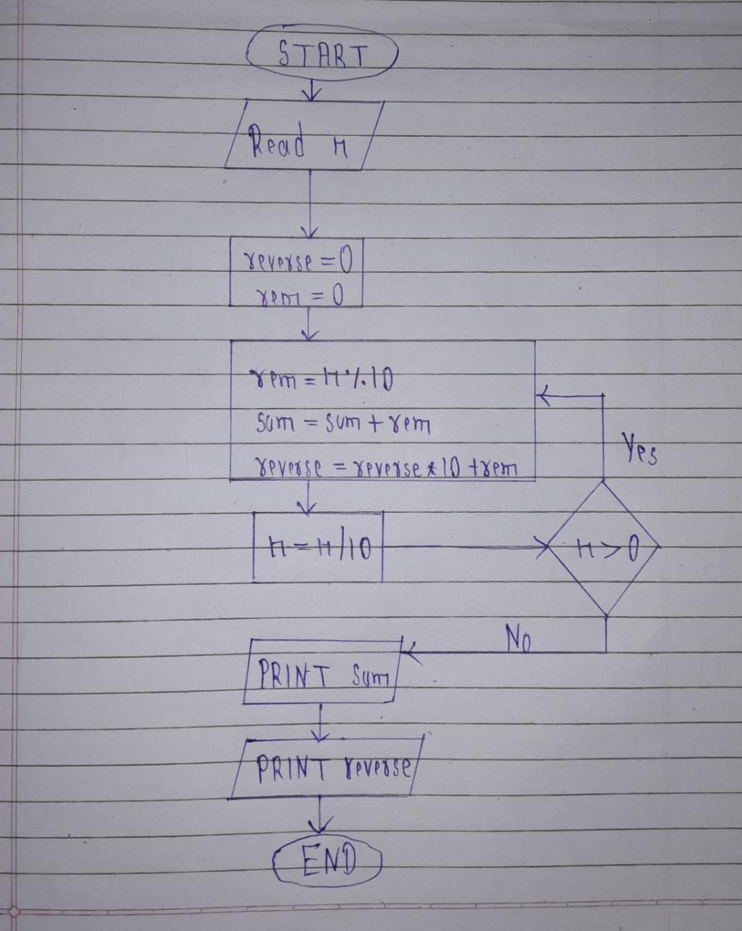

**code :**

#include<stdio.h>

#include<conio.h>

void main()

{

int num,rem,reverse=0,sum=0;

//clrscr();

printf("Enter a number:\n");

scanf("%d",&num);

while(num>0)

{

rem=num%10;

sum+=rem;

reverse=reverse*10+rem;

num/=10;

}

printf("\nAfter Reversing a number:\n%d",reverse);

printf("\nSum of all digit of a number:\n%d",sum);

getch();

}

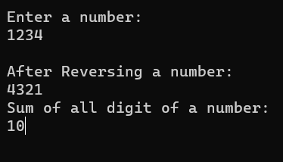**Output :**

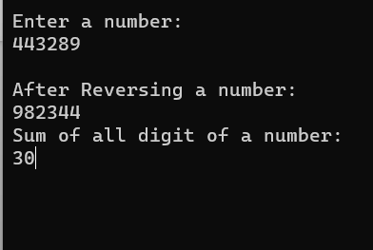

**Conclusion :**

We understand how to reverse a number and sum of all digits of a given number.

**Experiment No. 9**

Write programs to display each of the following patterns. Write algorithm and draw flowchart for the same

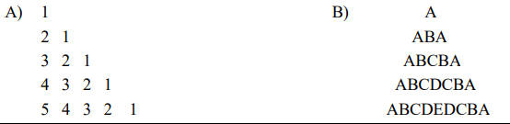

**Aim :**

study of pattern using loop

**Algorithm :**

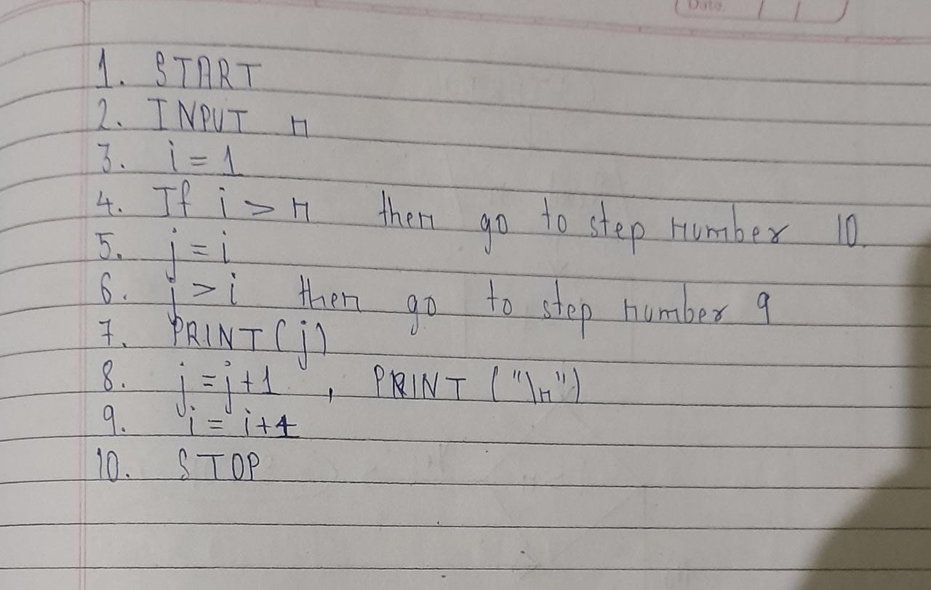

**Flowchart :**

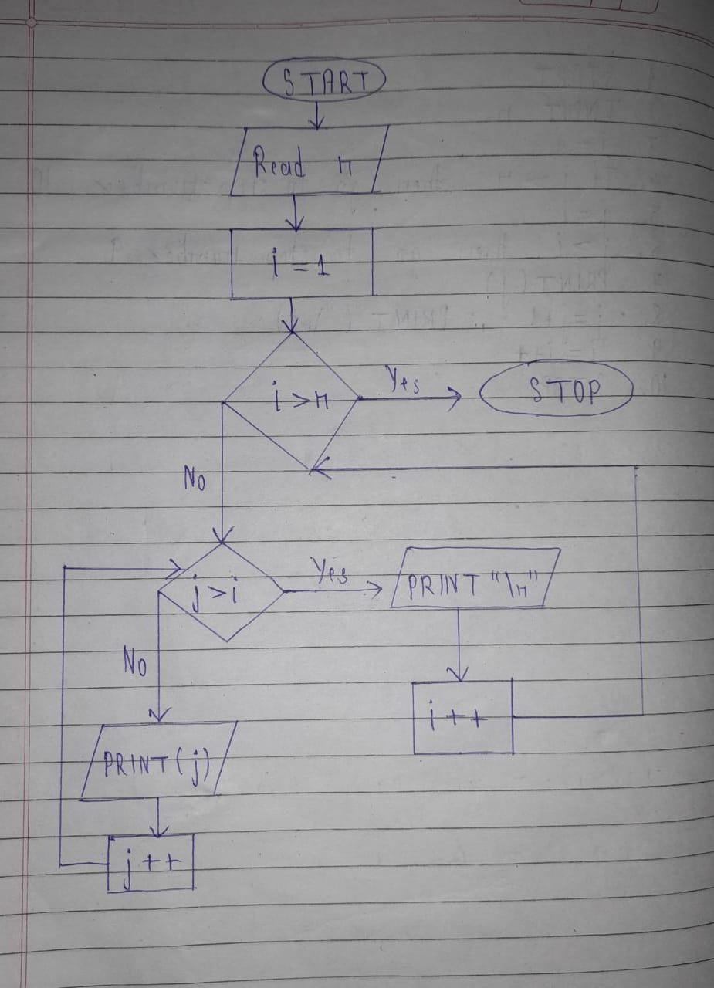

**Code :**

#include<stdio.h>

#include<conio.h>

void main()

{

int i,j,n;

//clrscr();

printf("Enter your n:\n");

scanf("%d",&n);

for(i=1;i<=n;i++)

{

for(j=i;j>=1;j--)

{

printf("%d ",j);

}

printf("\n");

}

}

**Output :**

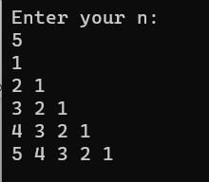

**B)**

**Algorithm :**

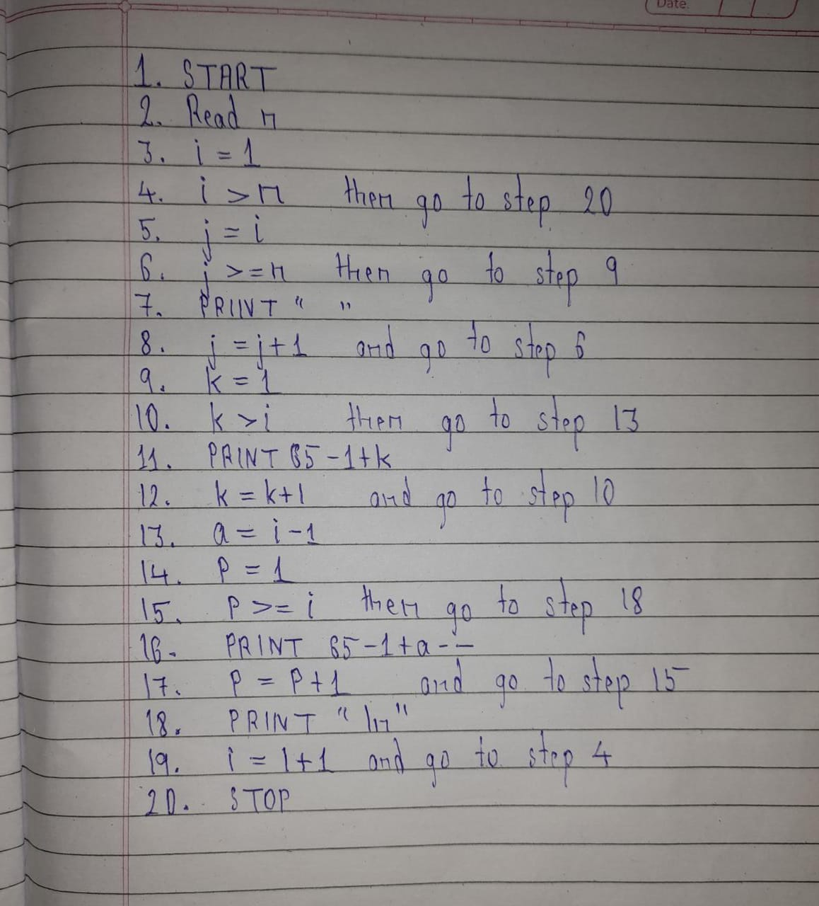

**Flowchart :**

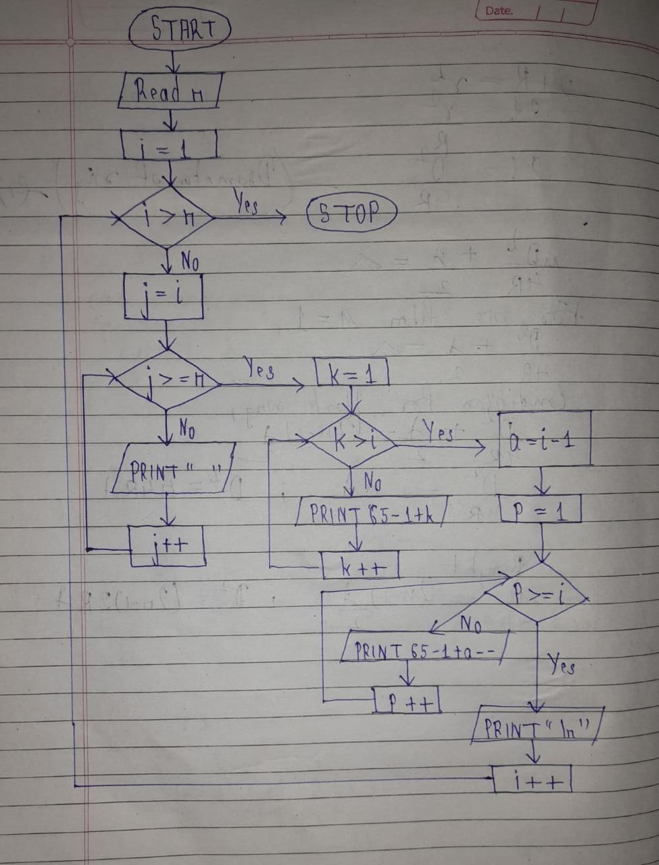

**Code :**

#include<stdio.h>

#include<conio.h>

void main()

{

int i,j,n,k,a,p;

//clrscr();

printf("Enter rows:\n");

scanf("%d",&n);

for(i=1;i<=n;i++)

{

for(j=i;j<n;j++)

{

printf(" ");

}

for(k=1;k<=i;k++)

{

printf("%c",65-1+k);

}

a=i-1;

for(p=1;p<i;p++)

{

printf("%c",65-1+a--);

}

printf("\n");

}

getch();

}

**Output:**

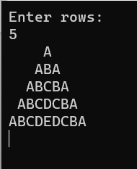

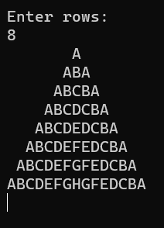

**Conclusion :**

We understand the concept of for loop and how to tackle pattern like problem.

**Experiment No. 10**

Write a C program to find maximum and minimum between two numbers using functions. Write algorithm and draw flowchart for the same.

**Aim :**

Study of function

**Algorithm :**

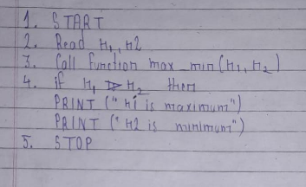

**Flowchart :**

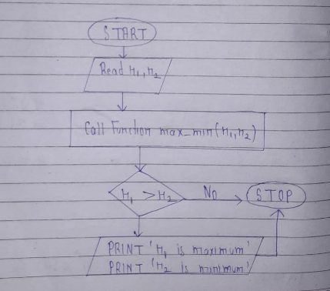

**Code :**

#include<stdio.h>

#include<conio.h>

void max_min(int n1,int n2);

void main()

{

int n1,n2;

//clrscr();

printf("Enter two number:\n");

scanf("%d %d",&n1,&n2);

max_min(n1,n2);

getch();

}

void max_min(int n1,int n2)

{

if(n1>n2)

printf("\n%d is maximum",n1);

printf("\n%d is minimum",n2);

}

**Output:**

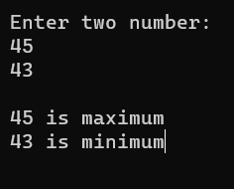

**Conclusion :**

We understand that how to use if else statement and how to check which is maximum or minimum number.